
Name: _________________________________

Task 2:

SOURCE ANALYSIS, FORTNIGHTLY TASK THREE Weighting 2% (9 Marks)

Question 1

- Explain the message of Source 1.
(3 marks)

- Identify how and discuss why Sources 1 and 2 are contestable.
(6 marks)

(Hint: When discussing contestability make sure that you explain whether each source provides a certain interpretation of events for which other interpretations exist or whether the sources can be disputed)

Source 1:
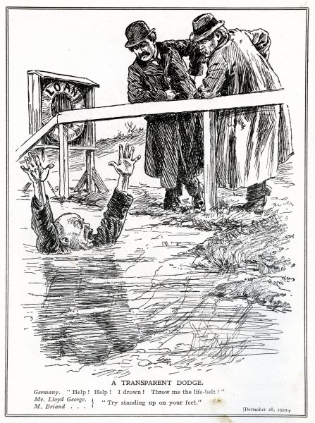

The image above is a British cartoon published in 1921. A “Transparent Dodge” means an obvious trick.

Source 2:
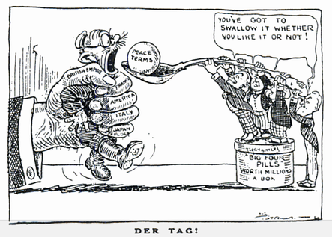

A British Cartoon titled “Der Tag” that was published in the Daily express in May 1919.

